NAME : ALVEENA NAZ
REG NO.FA25-BSE-010
ASSIGNMENT 4
DATE : 12/7/25

Question 1:
import java.util.*;
import java.io.*;
public class NewClass
{
public static void main (String[] args)
{
Scanner input = new Scanner(System.in);
ArrayList<Integer> roll = new ArrayList<>();
ArrayList<String> name = new ArrayList<>();
ArrayList<Integer> marks = new ArrayList<>();
try
{
FileOutputStream file = new FileOutputStream("student.txt");
PrintStream ps = new PrintStream(file);
//Data from user and write data
while(true)
{
System.out.println("Enter roll no. or 0 to exit.");
int rno = input.nextInt();
if(rno==0)
break;
input.nextLine();
System.out.println("Enter name of student");
String n = input.nextLine();
System.out.println("Enter marks of student");
int m = input.nextInt();
ps.println(rno);
ps.println(n);
ps.println(m);

}
file.close();
}
catch(Exception e)
{
System.out.println(e.toString());
}

Question 2:
import java.util.*;
import java.io.*;
public class NewClass
{
public static void main (String[] args)
{
Scanner input = new Scanner(System.in);
ArrayList<Integer> roll = new ArrayList<>();
ArrayList<String> name = new ArrayList<>();
ArrayList<Integer> marks = new ArrayList<>();
try
{
FileOutputStream file = new FileOutputStream("student.txt");
PrintStream ps = new PrintStream(file);
//Data from user and write data
while(true)
{
System.out.println("Enter roll no. or 0 to exit.");
int rno = input.nextInt();
if(rno==0)
break;
input.nextLine();
System.out.println("Enter name of student");
String n = input.nextLine();
System.out.println("Enter marks of student");
int m = input.nextInt();
ps.println(rno);
ps.println(n);
ps.println(m);

}
file.close();
}
catch(Exception e)
{
System.out.println(e.toString());
}

//Read file
try
{
int count =0;

File file = new File("student.txt");
Scanner sc = new Scanner(file);
while(sc.hasNext())
{
int rollNo = sc.nextInt();
String nm = sc.next();
int mk = sc.nextInt();

if(mk>50)
{
count++;
}
}
System.out.println("The number of students having marks greater than 50 is: " + count);
sc.close();
}
catch(Exception e)
{
System.out.println(e.toString());
}

}
}
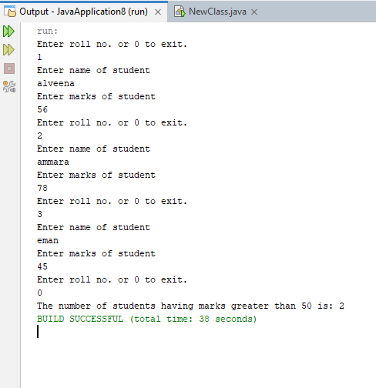

Question 3:
//Read file
try
{
File file = new File("student.txt");
Scanner sc = new Scanner(file);
while(sc.hasNext())
{
int rollNo = Integer.parseInt(sc.nextLine());
String nm = sc.nextLine();
int mk = Integer.parseInt(sc.nextLine());

if(mk==49)
{
mk = 50;
}
roll.add(rollNo);
name.add(nm);
marks.add(mk);
}
sc.close();

//convert list data into file
PrintStream ps = new PrintStream(file);
for(int i =0;i<roll.size();i++)
{
ps.println(roll.get(i));
ps.println(name.get(i));
ps.println(marks.get(i));
}

ps.close();

}
catch(Exception e)
{
System.out.println(e.toString());
}

}

Question 4:
//Read file
try
{
File file = new File("student.txt");
Scanner sc = new Scanner(file);
while(sc.hasNext())
{
int rollNo = Integer.parseInt(sc.nextLine());
String nm = sc.nextLine();
int mk = Integer.parseInt(sc.nextLine());

if(mk>=50)
{
roll.add(rollNo);
name.add(nm);
marks.add(mk);
}
}
sc.close();

//convert list data into file
PrintStream ps = new PrintStream(file);
for(int i =0;i<roll.size();i++)
{
ps.println(roll.get(i));
ps.println(name.get(i));
ps.println(marks.get(i));
}

ps.close();
// print updated data
for(int i =0;i<roll.size();i++)
{
System.out.println(roll.get(i)+ " " + name.get(i) + " " + marks.get(i));
}

}
catch(Exception e)
{
System.out.println(e.toString());
}

OUTPUT:
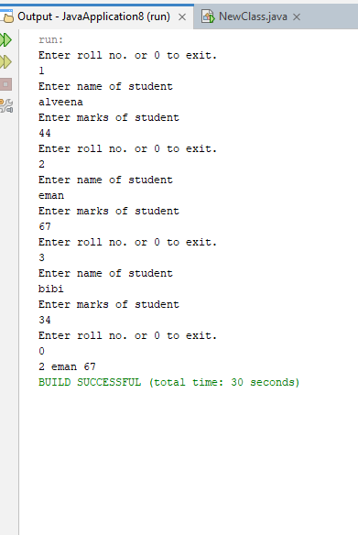

Question 5
import java.util.*;
import java.io.*;
public class NewClass
{
public static void main (String[] args)
{
Scanner input = new Scanner(System.in);
ArrayList<Integer> roll = new ArrayList<>();
ArrayList<String> name = new ArrayList<>();
ArrayList<Integer> marks = new ArrayList<>();
try
{
FileOutputStream file = new FileOutputStream("student.txt");
PrintStream ps = new PrintStream(file);
//Data from user and write data
while(true)
{
System.out.println("Enter roll no. or 0 to exit.");
int rno = input.nextInt();
if(rno==0)
break;
input.nextLine();
System.out.println("Enter name of student");
String n = input.nextLine();
System.out.println("Enter marks of student");
int m = input.nextInt();
ps.println(rno);
ps.println(n);
ps.println(m);

}
ps.close();
file.close();
}
catch(Exception e)
{
System.out.println(e.toString());
}

//Read file
int max =0;
String topper = "";
try
{
File file = new File("student.txt");
Scanner sc = new Scanner(file);
while(sc.hasNext())
{
int rollNo = Integer.parseInt(sc.nextLine());
String nm = sc.nextLine();
int mk = Integer.parseInt(sc.nextLine());

if(mk>max)
{
max = mk;
topper = nm;
}
else if(mk==max)
{
System.out.println("Topper is " + nm);
}

}
System.out.println("Topper is " + topper);

sc.close();

}
catch(Exception e)
{
System.out.println(e.toString());
}

}
}
